**EE3070 Technical Training Report**

Important Note: Copying other’s work (even partly) is considered as an academic dishonest, and the case will be reported to the University. It will lead to disciplinary action against students who were involved, including the one who copied the other and the original writer.

|  |
| --- |
| **Submission Instructions**   1. Each student has to submit his/her own report via Assignment in CANVAS. 2. File format: pdf; Filename: TR-Lxx-Gpy-SID.pdf (xx: lab session number, y: group number, SID: Your Student ID) 3. Deadline for submission:    * Students in LB1, LC1 (Mon session): 11:59pm 6-Oct-2021    * Students in L01, LA1, L02, LA2 (Wed sessions): 11:59pm 8-Oct-2021   **No late submission will be accepted.** |

Group No: L____ Gp ____

|  |  |
| --- | --- |
| Student Name | Student ID |
|  |  |

**I. Arduino Programming (Based on Technical Training I)**

**Task 1.1 (Answer the 10 questions given in the manual)**

|  |  |
| --- | --- |
| Questions | Your answers |
| 1. What is the operating voltage of Mega 2560 ver 3? |  |
| 1. In maximum, how many digital I/O pins you can assign in Mega 2560 ver 3? |  |
| 1. Which I/O pins can provide PWM output (give the pin numbers)? |  |
| 1. What is the smallest non-zero average voltage that PWM output can provide? |  |
| 1. How many pins can be used to read a sensor for which its output is ranged from 0V to 3V? |  |
| 1. Can we use an I/O pin to directly light up a LED if it needs 2V and 10mA (without using any driving circuit)? |  |
| 1. If you use your Arduino board to read an analog input, what is the possible largest digital value you obtained? |  |
| 1. How many serial communication pairs that Mega 2560 has? |  |
| 1. In maximum, how many bytes you can use for your program code? |  |
| 1. List all the pins that support external interrupts? |  |

**Task 1.2**

**Answer questions to get familiar with pin assignment for communications.**

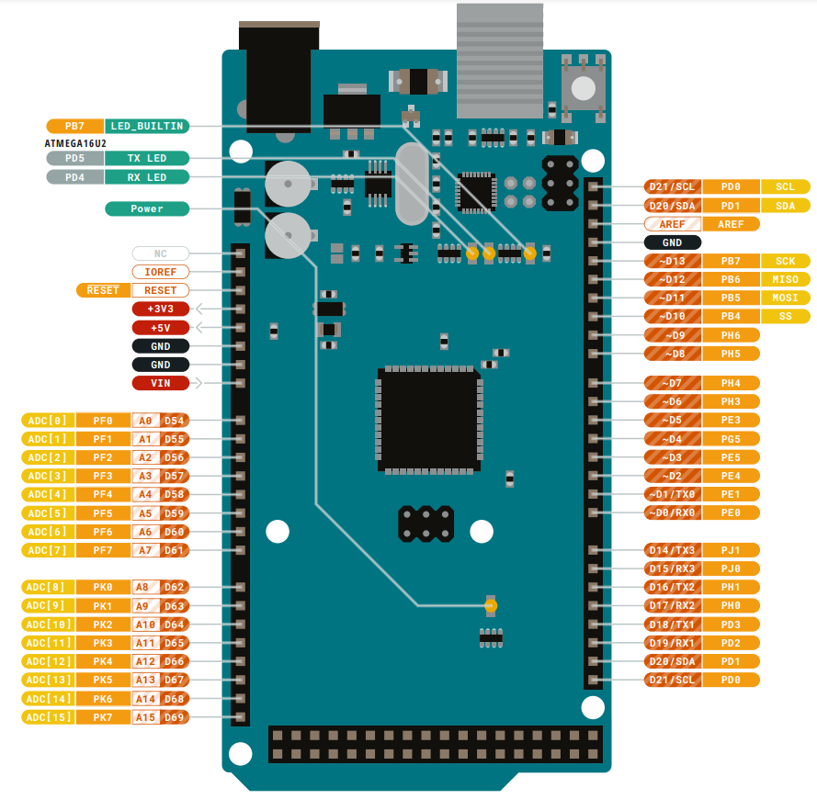

This project will make use of different types of serial communications. They are based on UART, I2C and SPI, respectively. [Please refer to Lecture notes]

1. There are four default UART Serial communications. One of them is also used for the Serial monitor (So, you are not to use that serial, if you use Serial monitor). Circle the transmitter and receiver pins of that serial port, and mark as UART.
2. I2C communications use 2 pins, one is clock SCL and one is data SDA. Circle the default pins that assigned for these functions, and mark as I2C.
3. SPI communications use 4 pins. They are clock (SCK), slave select (SS), master-input-slave-output (MISO) and master-output-slave-input (MOSI). Circle the default pins that assigned for these functions and mark as SPI.

**Task 2 Get Familiar with the project platform**

**Task 2.1**

|  |  |
| --- | --- |
| Modules | The name of the module |
| A |  |
| B |  |
| C |  |
| D |  |
| E |  |
| F |  |
| G |  |
| H |  |
| I |  |
| J |  |

**Task 2.2**

Explain how the driving circuit works to turn D2 on and off

|  |
| --- |
|  |

**Task 3. Programming Tasks**

**Task 3A: Display color with RGB LED**

1. Provide your connection (in simple block diagram)

Arduino

B.LED Input

G.LED Input

R.LED Input

Transistor driving circuit

RGB LED

Jumper box

1. Draw flow chart of your program
2. Provide your program list

**Task 3B.**

1. Give a description on your function mapping
2. Give your program listing

**Task 3C:**

1. Give a description on your function mapping
2. Provide your program listing

**II. Design Module (Based on Technical Training II)**

Technical Training II: Topic _____ (Input the topic number)

**II.A Design Task 1.**

|  |
| --- |
| Section 1A. Task description   * Describe the task in your own words |
| Section 1B. Hardware settings   * Draw a block diagram about the connections and describe the hardware settings |
| Section 1C. Software design   * Put the program codes as appendix at the back of report, eg. Appendix: Task 1 Code. * State at least 3 key points for the design, and explain why they are important (eg. how you set the pins in software to match with hardware; how to control the I/O; how to set the parameters; … ) |

**II.B Design Task 2.**

|  |
| --- |
| Section 2A. Task description   * Describe the task in your own words |
| Section 2B. Hardware settings   * Draw a block diagram about the connections and describe the hardware settings * Note: If the task has the same setup as before, you may just refer to the figure as given in your report. |
| Section 2C. Software design   * Put the program codes as appendix at the back of report, eg. Appendix: Task 2 Code. * State at least 3 key points for the design, and explain why they are important (eg. how you set the pins in software to match with hardware; how to control the I/O; how to set the parameters; … ) |

**II.C Design Task 3.**

|  |
| --- |
| Section 3A. Task description   * Describe the task in your own words |
| Section 3B. Hardware settings   * Draw a block diagram about the connections and describe the hardware settings * Note: If the task has the same setup as before, you may just refer to the figure as given in your report. |
| Section 3C. Software design   * Put the program codes as appendix at the back of report, eg. Appendix: Task 3 Code. * State at least 3 key points for the design, and explain why they are important (eg. how you set the pins in software to match with hardware; how to control the I/O; how to set the parameters; … ) |

**II.D Advance Design Task 1 (if you have attempt)**

|  |
| --- |
| Section 4A. Task description   * Describe the task in your own words |
| Section 4B. Hardware settings   * Draw a block diagram about the connections and describe the hardware settings * Note: If the task has the same setup as before, you may just refer to the figure as given in your report. |
| Section 4C. Software design and explanation   * Put the program codes as appendix at the back of report, eg. Appendix: Task 4 Code. * Explain your design (how it can achieve the task) |

**[Add more sections if needed]**

**II.E Discussions**

* Answer the questions in the manual
* Briefly summarize what you learnt